Title: An Application that Drafts Summary Emails with the Help of ChatGPT -

Final Report

Department of Computer Science, The University of Hong Kong  
Kwok Hin Tsoi - 3035743223

Supervised by Professor Xu, Dong

## 

## Abstract

In this fast-paced digital era, email communication plays a vital role in our personal and professional lives. However, the overwhelming amount of emails we receive daily can be time-consuming and cumbersome to manage. This essay explores the development of an innovative application that leverages GmailAPI to access users' emails and utilizes ChatGPT API to draft summary emails. The main objective is to streamline the email drafting process and enhance users' productivity by providing a convenient way to communicate with targeted recipients.

The application harnesses the power of GmailAPI, which enables seamless access to users' emails, including inbox, drafts, and sent items. By utilizing the GmailAPI, the application ensures secure and efficient retrieval of email data, allowing users to effortlessly interact with their email accounts.

To draft summary emails, the application integrates ChatGPT API, a state-of-the-art language model. By communicating with ChatGPT API, users can compose concise and coherent summaries of their emails, eliminating the need for lengthy and repetitive responses.

The benefits of this application are twofold. First, it saves users' valuable time by automating the email drafting process, reducing the need for manual summarization. Second, it enhances communication effectiveness, as the summary emails provide recipients with concise and relevant information, increasing clarity and reducing information overload.

This essay will delve into the technical aspects of integrating GmailAPI and ChatGPT API, discussing the challenges encountered during the development process and the solutions implemented. Additionally, it will highlight the potential impact of this application on individuals and organizations, emphasizing the improved efficiency and effectiveness of email communication.

By combining the power of GmailAPI and ChatGPT API, this application offers a novel approach to email management, revolutionizing the way we draft and send emails. It paves the way for more streamlined and productive communication, empowering users to focus on what truly matters.

## Table of Contents

**Table of Contents** **IV**

**List of Figures** **V**

**Abbreviations** **VI**

**Introduction 1**

**Methodology 2**

**Result and Discussion 3**

**Challenges** **6**

**Future Plan** **8**

**Conclusion** **8**

**References** **10**

## List of Figures

Figure 1 User interface of the application (original state)**3**

Figure 2 Login Webpage**3**

Figure 3 User interface of the application (after login)**4**

Figure 4 User interface of the application (after entering recipient email)**4**

Figure 5 User interface of the application (final result)**5**

## 

## Abbreviations

| Abbreviation | Definition |
| --- | --- |
| API | Application Programming Interface |
| UI | User Interface |
| AI | Artificial Intelligence |

## 

## Introduction

In today's fast-paced work environment, managing emails has become a significant time-consuming task for professionals. According to Chui et al. (2012), workers spend an average of 28% of their work time on email management. This statistic highlights the need for innovative solutions to streamline the email drafting process and enhance productivity. With the recent advancements in Artificial Intelligence (AI), the development and implementation of an email drafting application hold immense potential to revolutionize email communication and improve efficiency.

The aim of this paper is to present the development and implementation of an innovative email drafting application that leverages AI technologies. This application aims to provide users with a seamless and efficient way to draft summary emails by integrating GmailAPI and ChatGPT API. By automating the summarization process and improving communication effectiveness, this application has the potential to significantly enhance productivity and save valuable time for workers.

The subsequent sections of this paper will delve into the methodology employed for developing the application. The "Methodology" section will provide insights into the approaches and strategies used in creating this application. Following that, the "Results and Discussion" section will highlight the successfully implemented features of the application, shedding light on its functionality and benefits. Furthermore, the "Challenges" section will explore potential obstacles that may arise during the development and implementation process and propose effective solutions to overcome them.

Finally, the "Conclusion" section will summarize the accomplishments of this project and discuss the overall impact and benefits of the email drafting application. By harnessing the power of AI and integrating GmailAPI and ChatGPT API, this application has the potential to transform the way we manage and draft emails, leading to improved productivity and streamlined communication.

Through the careful exploration of the aims, implementation strategies, successfully implemented functions, potential challenges, and conclusion of this paper, readers will gain a comprehensive understanding of the development and potential impact of the email drafting application. It is our hope that this research will contribute to the advancement of email management practices, empowering professionals to maximize their productivity and efficiency in the digital age.

## Methodology

The email drafting application was developed targeting the Windows platform, specifically catering to Gmail users. Python was chosen as the primary programming language for both the client-side and server-side development, owing to its versatility and extensive library support. Four key libraries were utilized to facilitate the implementation of various functionalities.

PyQt5:

To create a user-friendly and intuitive graphical user interface (GUI), the robust PyQt5 library was employed. PyQt5 provides a wide range of tools and widgets that enabled the development of a visually appealing and interactive interface for users to interact with the application seamlessly.

PyInstaller:

PyInstaller played a crucial role in simplifying the distribution and installation of the application. By using PyInstaller, the Python code was bundled into a standalone executable file, eliminating the need for users to install additional dependencies or set up complex environments.

OpenAI:

To integrate the powerful language model into the application, the OpenAI library was utilized. OpenAI's ChatGPT API enabled the communication between the application and the language model, facilitating the generation of concise and coherent email summaries. This integration enhanced the efficiency and effectiveness of the email drafting process.

Google-related libraries:

To connect and interact with Gmail, various Google-related libraries were employed. These libraries, provided by Google, offered convenient methods and functionalities to access Gmail's API. By leveraging these libraries, the application seamlessly accessed users' emails, drafts, and sent items, ensuring secure and efficient retrieval of email data.

## Results and Experiment

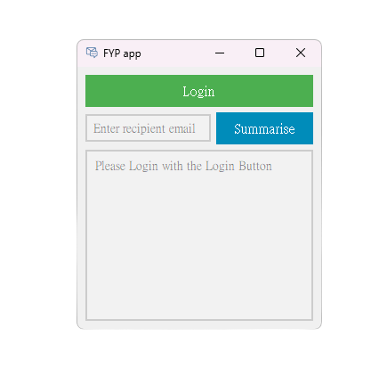

#### Figure 1 User interface of the application (original state)

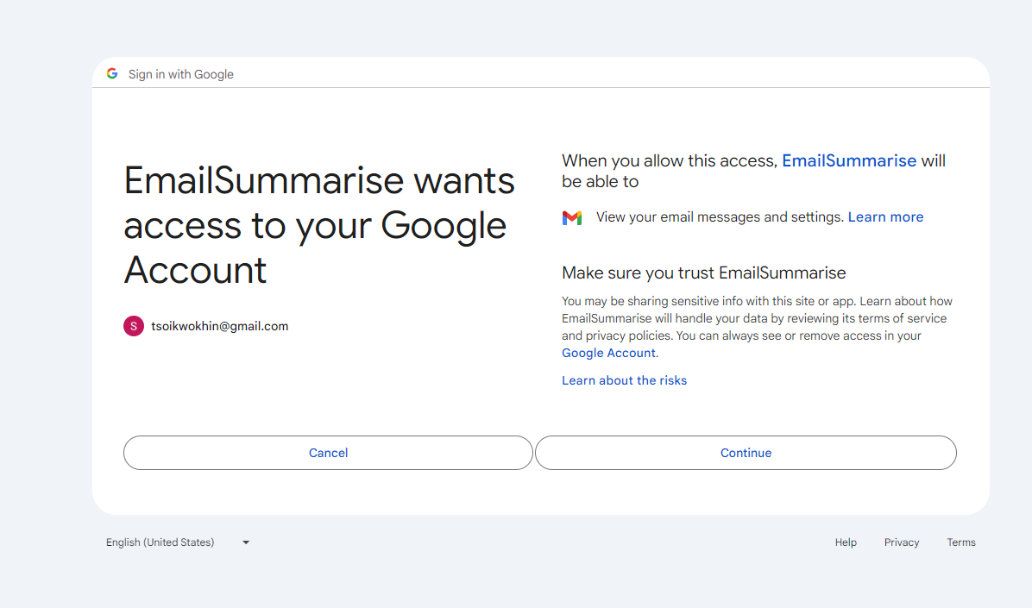

Figure 2 Login Webpage

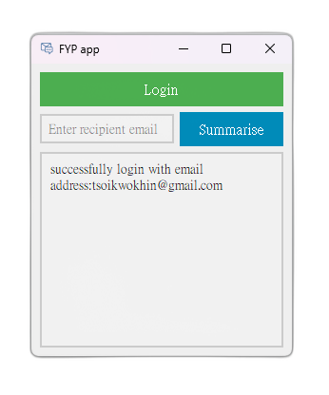

#### Figure 3 User interface of the application (after login)

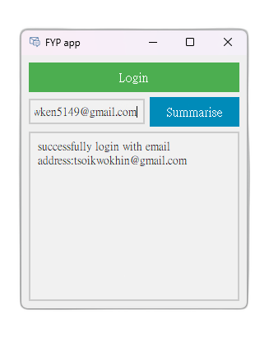

Figure 4 User interface of the application (after entering recipient email)

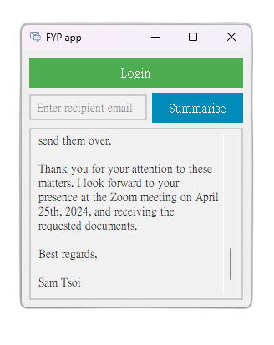

#### Figure 5 User interface of the application (final result)

To demonstrate how the email drafting application works, the following steps were implemented:

1. The user logs in to their Gmail account within the application.
2. The user enters the recipient's email address.
3. Upon pressing the "Summarize" button, the application initiates a search for recent emails within the past week.
4. The application sends the email data to the server for further processing.
5. The server communicates with the ChatGPT API to generate a summary of the email content.
6. The server then sends the generated summary back to the user.
7. The application displays the summary in the output box for the user to review.

Beta test user opinions highlighted a few areas for improvement:

1. Waiting Time: Some users experienced longer waiting times during the summarization process. This delay may have occurred due to ChatGPT API instability.
2. Weird Results: Occasionally, the generated summaries may have contained text that seemed irrelevant or unrelated to the original email content. This inconsistency in results could be attributed to the limitations of the language model or the quality of training data.
3. Limited Filtering Options: Users expressed a desire for more filtering options to narrow down the search for recent emails. This feedback suggests that the application could benefit from additional features to enhance the user's control over the email selection process.

Solutions:

1. ChatGPT Instability: Unfortunately, the issue of ChatGPT API instability is beyond the scope of the application's development. However, the application can display a clear message to users indicating that the summarization process may take longer due to external factors.
2. Irrelevant Text Removal: To address the issue of irrelevant text in the generated summaries, further improvements can be made by implementing additional text processing techniques. These techniques could involve removing irrelevant sentences or improving the model's training to enhance the relevance and coherence of the generated summaries.

## Challenges

During the development and implementation of the email drafting application, several challenges were encountered. These challenges required careful consideration and innovative solutions to ensure the successful functioning of the application. The following are some of the notable challenges faced:

1. Integration with Gmail API: Integrating the application with the Gmail API posed a significant challenge. The Gmail API provides a wide range of functionalities, including email retrieval, sending, and management. However, understanding and implementing the API's various endpoints and authentication mechanisms required thorough research and attention to detail.
2. Communication with ChatGPT API: Establishing seamless communication between the application's server and the ChatGPT API was another challenge. Ensuring a secure and reliable connection, handling requests and responses, and managing potential latency issues required careful implementation and testing.
3. Data Security and Privacy: Maintaining the security and privacy of users' email data was of utmost importance. Implementing robust security measures, including encryption and secure storage of user credentials, was necessary to protect sensitive information and ensure user trust in the application.
4. User Experience and Interface Design: Creating a user-friendly and intuitive interface that seamlessly integrates with Gmail and provides a smooth user experience was a challenge. Designing an interface that accommodates different user preferences, handles errors gracefully, and provides clear instructions required careful consideration of user feedback and iterative design improvements.

Overcoming these challenges required a combination of technical expertise, innovative problem-solving, and iterative development processes. By addressing these challenges head-on, the email drafting application was able to provide users with a valuable tool for streamlining their email management process and enhancing productivity.

## Future Plan

To enhance the application further, future development could focus on the following areas:

1. Improved Filtering Options: Incorporating additional filtering options, such as date range selection or keyword-based filtering, would provide users with more control over the emails included in the summarization process. This feature would allow users to retrieve more relevant and targeted information.
2. User Customization: Introducing customization options, such as selecting the level of summarization or specifying preferred summarization styles, would enable users to tailor the application to their specific needs and preferences.
3. Performance Optimization: Continual optimization of the application's performance, including reducing waiting times and enhancing overall responsiveness, would enhance the user experience and ensure efficient email management.

By addressing these suggestions and continually refining the application, it has the potential to become a valuable tool for Gmail users, improving their email management efficiency and productivity.

## Conclusion

In conclusion, the development and implementation of the email drafting application have shown promising results in addressing the challenges of email management and enhancing productivity. By leveraging AI technologies and integrating with Gmail API, the application offers users a seamless and efficient way to draft email summaries.

Through the utilization of libraries such as PyQt5 for the graphical user interface, PyInstaller for easy distribution, Google-related libraries for Gmail integration, and OpenAI for language model communication, the application successfully achieves its goals. It provides users with a user-friendly interface, secure access to Gmail, and generates concise email summaries using ChatGPT API.

However, it is important to acknowledge some challenges encountered during the development process. These challenges included integrating with Gmail API, communicating with ChatGPT API, ensuring data security and privacy, and optimizing the user experience and interface design. These challenges were addressed through thorough research, innovative solutions, and continuous refinement.

In the future, the application could benefit from further enhancements, such as improved filtering options, customization features, and performance optimization. These developments would provide users with more control, customization, and efficiency in managing their emails.

Overall, the email drafting application represents a significant step towards revolutionizing email management and improving productivity in the digital age. By automating the summarization process and enhancing communication effectiveness, the application empowers professionals to make the most of their work time and streamline their email workflows.

Through the accomplishments and ongoing advancements of this application, it is evident that the integration of AI technologies has the potential to transform email management practices, leading to increased efficiency and improved productivity for users.

## References

Chui, M., Manyika, J., Bughin, J., Dobbs, R., Roxburgh, C., Sarrazin, H., Sands, G., &

Westergren, M. (2012). The social economy: Unlocking value and productivity

through social technologies. McKinsey. Retrieved from https://www.mckinsey.com/

industries/technology-media-and-telecommunications/our-insights/the-social-econom

y